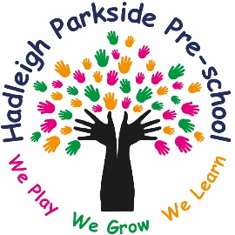

We have an exciting new position for a Early Years Practitioner at Hadleigh Parkside Pre-school.
As an Early Years Practitioner, you will be responsible as a key person to ensure you plan and provide stimulating activities to stretch children’s learning using your knowledge of each individual child’s interest. You will need to be confident in speaking to parents, work well within a team and communicate effectively with others. (This list is not an exhaustive and a full job description is available on request).
This position require flexibility of working between 8am – 6pm and during our holiday clubs which runs 9am-3pm.
This position also requires you to attend mandatory training, be keen to continue your own continual professional development and attend a staff meeting on the first Tuesday of every month 6pm-8pm.
You should have at least a level 3 in childcare.
The Pre-School offers term time care, wrap around care and holiday clubs for children from 18months - 5 years, and out-of-school care for children up to 6 years old.
Find out more about us by visiting our Facebook page: Hadleigh Parkside Pre-School, call our friendly team for an informal chat on 01473 827702 and speak to Megan Josselyn or Mica Robinson.
Please send CV’s and cover letter to office@hadleighparksidepre-school.co.uk.
Hours and rate of pay will be discussed at an interview.

